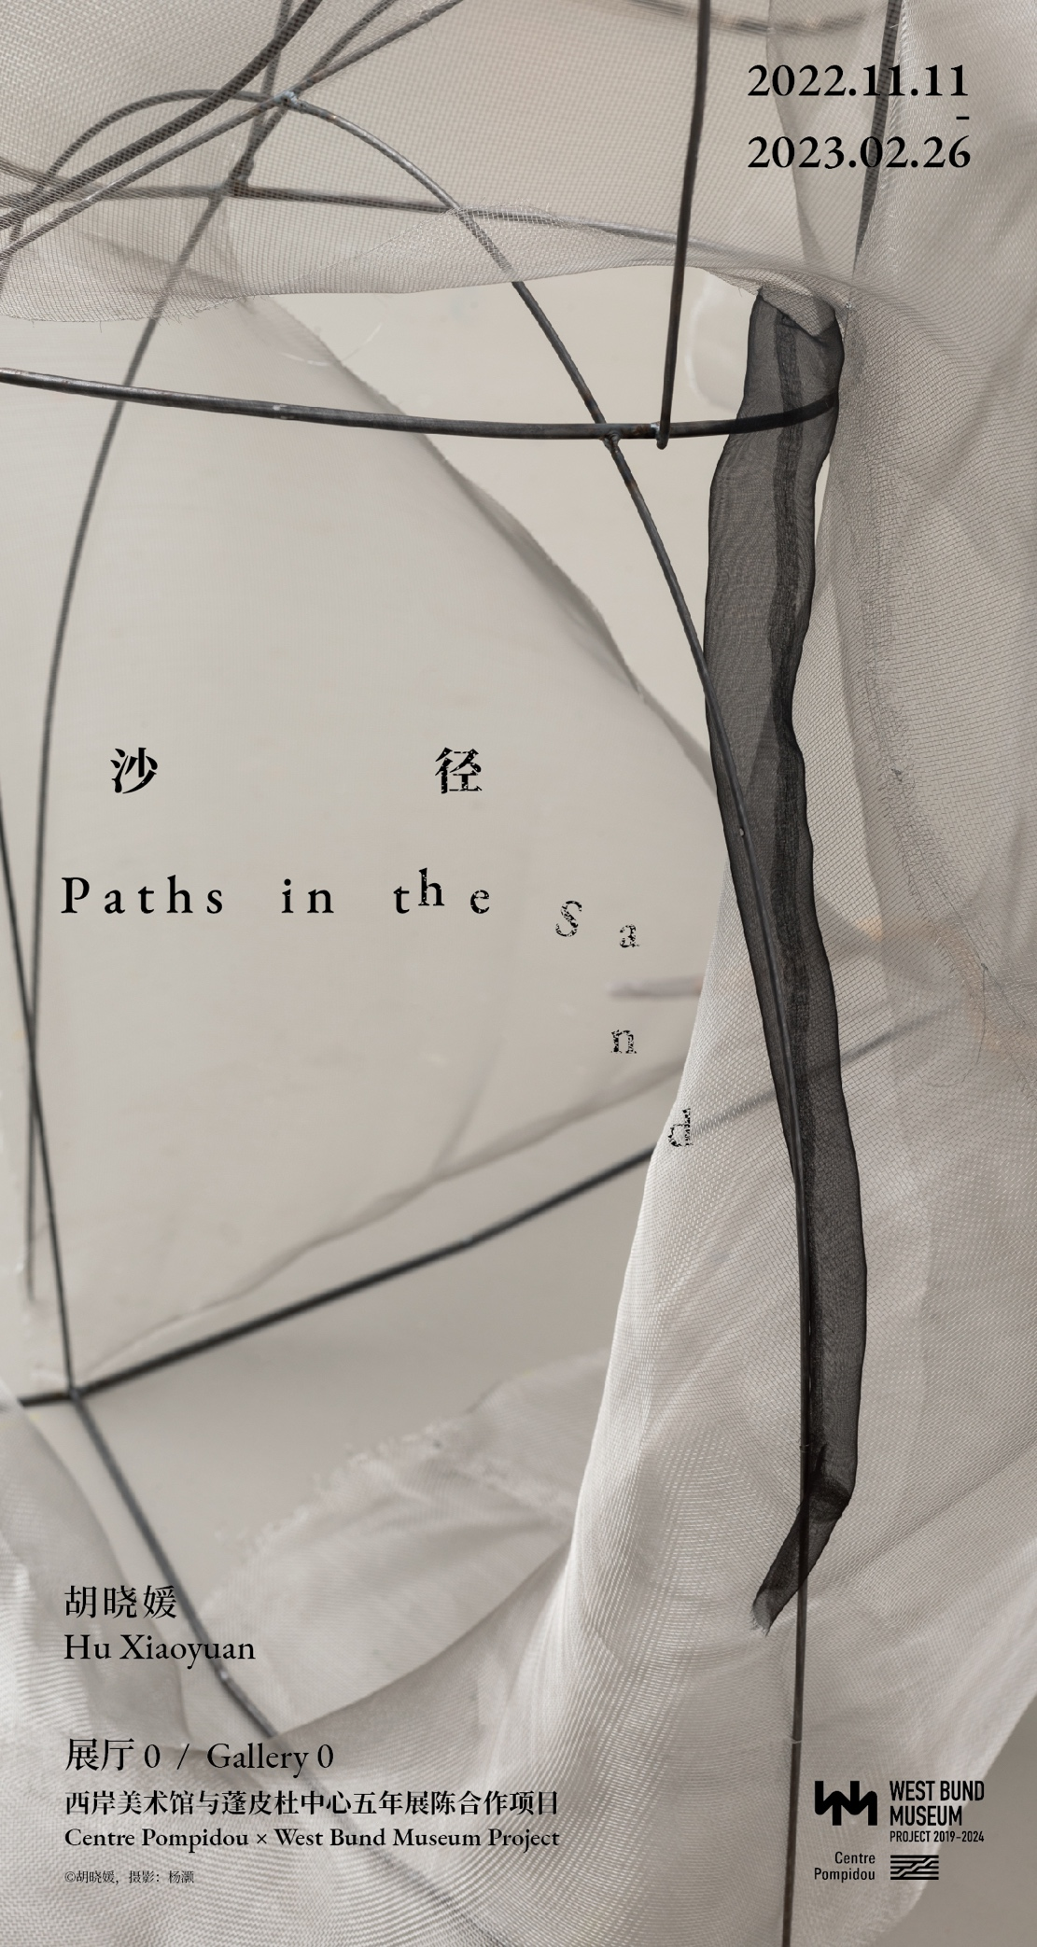

--
For Immediate Release

Centre Pompidou × West Bund Museum Project
Hu Xiaoyuan: Paths in the Sand
11 November 2022 – 26 February 2023 | Gallery 0

From 11 November 2022 to 26 February 2023, the Centre Pompidou × West Bund Museum Project presents an original project by Hu Xiaoyuan, entitled Paths in the Sand. Known as the first ever female Chinese artist to be invited to Kassel Documenta, Paths in the Sand is also Hu's first museum project in China in recent years. The exhibition in the Gallery 0 of the West Bund Museum will be inaugurated during Shanghai Contemporary Art week. For the occasion, Hu Xiaoyuan has created a labyrinthine cavity, where viewers will begin the journey of choices to explore the different dimensions of time and materials the moment they step into the gallery.

The Chinese exhibition title contains an extra space between the characters for “paths” and “sand”, which signifies the artist’s philosophical thinking of “paths” and “choices”. The artist maps out routes, understanding that human behavior is ultimately unpredictable no matter how effective the subliminal messaging is; she expects the unexpected. People’s paths and choices will eventually make an imprint of existence with huge difference on the exhibition space.

With a career over twenty years, Hu Xiaoyuan’s artistic style has always been dominated by delicate, analytical, and implicit contradictions. Her cross-media works include installation, painting, and multimedia. For the show in Gallery 0, the enclosed space has been transformed into a small labyrinth by elaborate partitions achieved with multiple means. The viewer moves or is led through the gallery actively or passively according to elements such as sounds, visuals, bodily sensations, relative scale, light, shadow, etc.

More than ten artworks in Paths in the Sand are exquisite, like poems that give one goosebump; restraint and sensuality, sharpness and tenderness, organic and inanimate, fragile or indurative, temporary or eternal, at here their existences juxtaposed. Hu Xiaoyuan has been studying and working with raw silk for many years. The material, pliable and translucent, easy and subtle to the touch, comes with a long tradition. Contrary to its light and soft texture, the production of raw silk involves cooking cocoons and reeling silk, which is seemingly violent and laborious. Material such as dry and stale bread and discarded space grade aluminum panels are found objects embedded with snippets of their previous owners; they are deconstructed in a collapsed temporal-spatial continuum, becoming symbolic expressions for the passing of time. Each choice is almost undiscernible in the running river that is life.

On the opening day, sound performance artist Lao Dan will be invited to perform with flute and saxophone, walking through gallery 0 like a viewer, engaging in an impromptu dialogue with Hu Xiaoyuan's work. The on-site recordings will be post-produced and re-presented as part of the exhibition, functioning as one of the sound inducements that drive the audiences’ subconsciousness forward.

