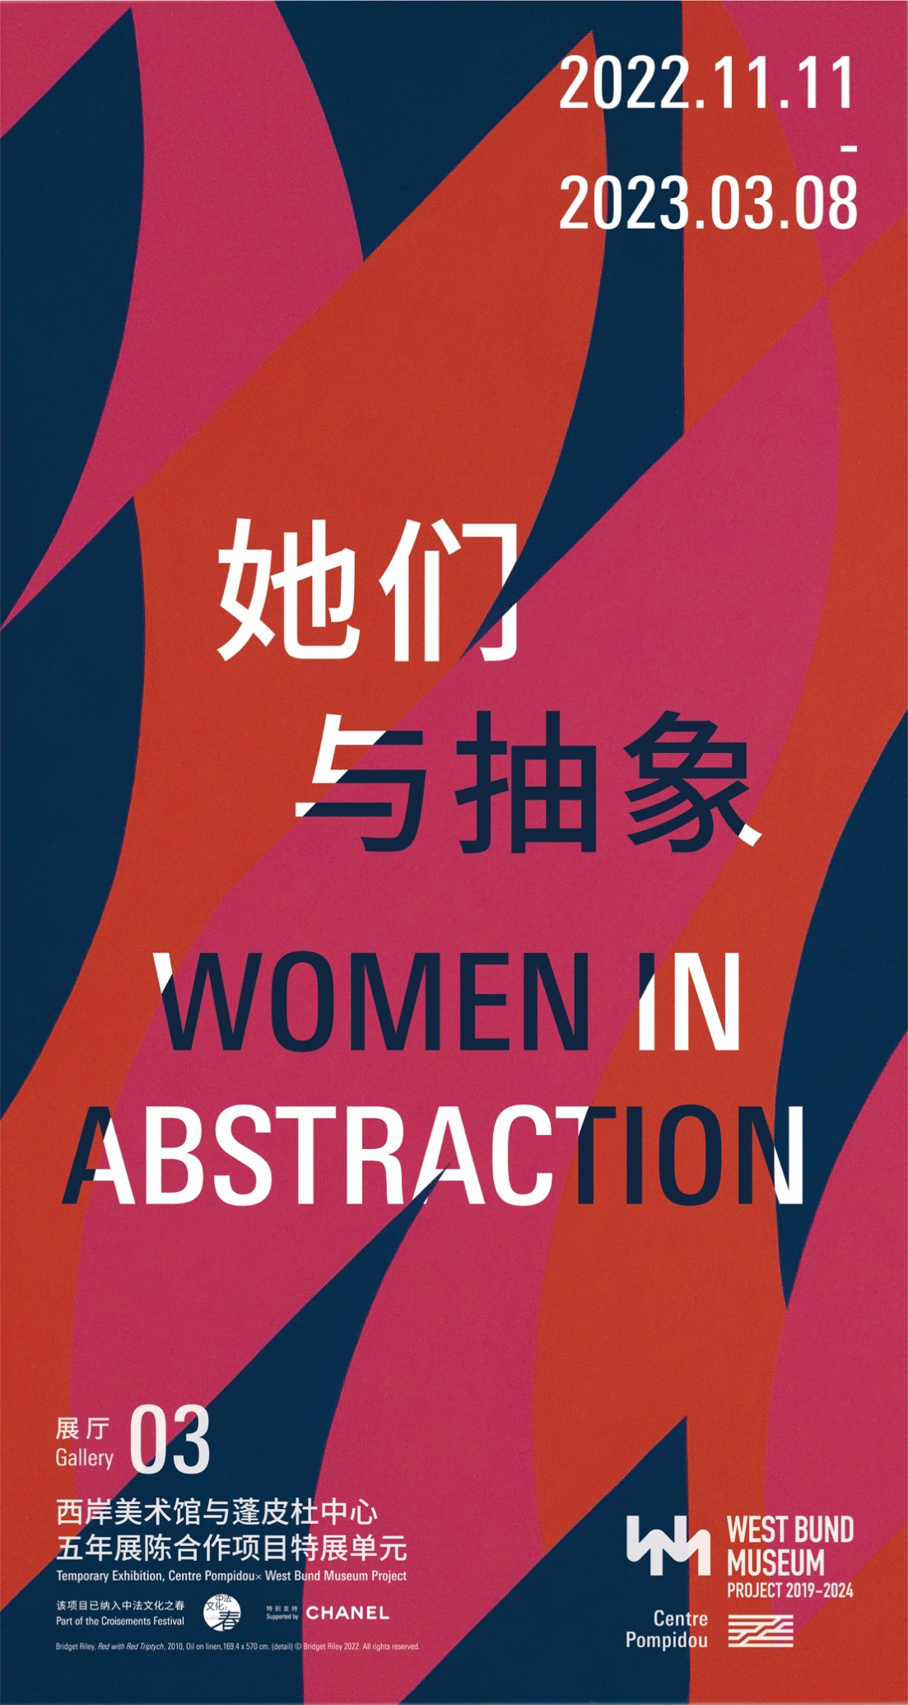
Press Release
For Immediate Release

Women in Abstraction
November 11^{h} 2022 - March 8th 2023 | Gallery 3

The exhibition "Women in Abstraction" sets out to write an alternative history of 20th century abstraction in the West, with some original incursions into the 21st century. The first version of the exhibition, which brought together more than one hundred artists, was held at the Centre Pompidou from 18 May to 23 August 2021 and at the Bilbao Guggenheim Museum from 21 October 2021 to 27 February 2022. This exhibition is supported by CHANEL and one of the highlights of 2022 Croisements Festival organized every year by Institut Français in China.

The majority of exhibitions devoted to abstraction have often downplayed the fundamental role of "women artists" in the development of this plastic language in the modernities. "Women in Abstraction" at the Centre Pompidou Paris ("Elles font l’abstraction") and at the Bilbao Guggenheim ("Mujeres de la abstracción") enabled a revaluation of the importance of the contributions of a great many female artists. For the Centre Pompidou × West Bund Museum Project in Shanghai, Christine Macel presents an original reconfiguration of the exhibition based on the works in the Centre Pompidou collection. An ensemble of thirty-four artists and nearly 100 works diverse in nature, ranging from painting to film, sculpture to photography and installation, will be presented in a chronological layout covering the period from the late 19th century to the present day.

This history of abstraction has been extended to many mediums and thus begins with a presentation of Loïe Fuller’s Serpentine Dance, which fascinated the Parisian public in the late 19th century. This layout is rooted in the European modernist avant-gardes, with an ensemble of works by Sonia Delaunay-Terk evoking the importance of her simultaneous art and her links to literature. Several theme-based rooms bring together artists who participated in the same trend: a room is thus dedicated to the abstractisation of reality by photographers as early as the 1920s; another to the development of optical and kinetic art in Europe and the United States in the 1960s. Other rooms present artists who shared the same sensibility: major painters like Joan Mitchell, Helen Frankenthaler and Shirley Jaffe are thus brought together in a room dedicated to Abstract Expressionism in the 1950s. The monumental works of several artists, who were essential to the development of textile sculpture in Europe and the United States and whose work is often grouped together under the term "Fiber Art", chime with each other in another room (Magdalena Abakanowicz, Jagoda Buić, Sheila Hicks, Rosemarie Castoro).

A catalogue is published for the exhibition. It brings together two major essays by Christine Macel and Griselda Pollock, an author who has been translated into Chinese for the first time. Notes are also dedicated to each of the artists presented in the exhibition. Finally, a bibliography brings together the main publications and exhibition catalogues that constitute key moments in the history of abstraction.

Publication of the proceedings of the international colloquium "Elles font l’abstraction" organised on 19 and 20 May 2021 by Christine Macel and the Centre Pompidou’s Speech department with the association Aware and the support of Catherine Petitgas in issue 159 of the Cahiers du Musée national d’art moderne "Elles font l’abstraction, le colloque".

